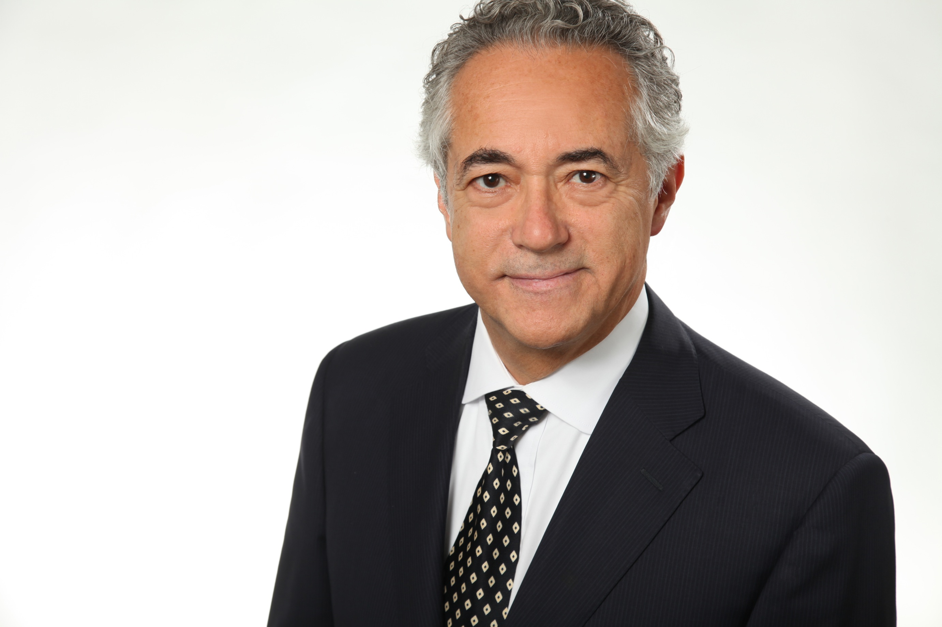
QUALIFICATION PROFILE
Name: | Walter E. Fritzsche  Mechanical Engineer
Company: | OBR organization consulting and implementation
Street: | Riemannstraße 92i
Zipcode: | 23701
City: | Eutin
Country: | Germany
Telephone: | +49 (0) 4521 7943299
Mobile: | +49 (0) 172 8474549
E-Mail: | info@obr-fritzsche.de
Homepage: | www.obr-fritzsche.de
Birth Day: | 10. December
Nationality: | German
Education: | Mechanical Engineer
IT experience since: | 1980
Languages​​: | German, Spanish, English
Areas of specialization: | Project management, Coaching, Change management, Project controlling,  Quality management, Test management, SAP Consultant (MM / DM / BCA), Master Data Management, sustainable ecology in projects and companies (company-vision, -identity, -values, -convictions, -skills, -behaviors)
Sectors | Mechanical engineering, retail, banks, e-commerce, television stations, insurance
Hourly rate: | Depending on location, duration and task: 110 - 150 EUR
Gulp-ID: | 1172
Availability date: | Not available
Experience, knowledge, training
Experience: | Banking, insurance:  • project management, change management, quality management,  implementation of SAP DM, BCA, FSCD, FI master data management,  migration, application support; IFRS9, IFRS16, EU-DSGVO  In mechanical engineering (special purpose machinery):  • project management, change management, organization,  master data management, migration, streamline business processes,  system analysis, design of complex functions  Trading company:  • project management, master data management SAP MM,  change management, quality management, test management  TV station:  • coaching of project management, project controlling, quality management,  test management  eCommerce:  • project management, product development, quality management,  search engine optimization, usability
Methods: | agile development, PMO, risk-based structured test approach, equivalence class analysis, cause-effect analysis, limit analysis, interview techniques, vision-based change work (company Vision, -Identity, values​​, ...)  Content Free Coaching, Mentoring  ITIL Framework (focus on Service Design, Service Transformation, Service Operation)
Standards: | Business process analysis (ARIS), structured programming, accessibility by BIVT, MS Office (Word, Excel, PowerPoint, Outlook, Access)
Software and Tools: | applications: SAP DM, BCA, ERP, MM, FSCD, SAP Solution-Manager;  CSC ADD;  Job control: ControlM  Tools: toolset for the development of COBOL, SQS test tools  Macromedia Studio, TYPOlight / CONTAO
Education &  training: | 1974 Mechanic  1979 Mechanical Engineer  1980 HP 3000 System management  1982 COBOL  1986 Instructor for IT merchants  1987 IHK auditor for IT merchants  1997 Systematic test case creation, test data creation - SQS Tools  2002 SAP Overview, System Architecture, Administration and BCA  2004 Internet Design & -programming with Macromedia MX  Dreamweaver, Fireworks, Cantao  2005 SAP AM  2006 BIVT- Conformity of web accessibility design  2007 SAP MM  2017 ITIL Foundation Certificate
Special non-IT skills | 1996 NLP Master training  2001 Vision-based change, coaching  2007 Transparent – Therapy

Project History
From: 06.20 to: |  | Sector: Bank – Central Bank
Topic: |  | Quality management
Project: |  | Developements, Upgrades, Projekts KTO2 (SAP BCA), EZB integration
From: 01.18 to: 12.19 |  | Sector: Insurance
Topic: |  | Testmanagement & Test coordination
Project: |  | Migration of WebMethods Engine 9.6 auf 9.12 & SAP FS-CD / FI and Projects (EU-DSVGO), IFRS16, SAP FI, IFRS9, OKB-BauFI, Finance Suite
From 10.16 to: 05.17 | Sector: Insurance
Topic: | Subproject management & test coordination
Project: | Project description: Dark processing of occupational retirement provision (BAV) & IIT (Individual IT) reorganization
From 03.15 to: 09.16 | Sector: Insurance
Topic: | Project management  Agile Project (SCRUM)
Project: | Project description: Data supply for a new sales and CRM system. (Mass data supply from a variety of supplying business systems)
From 01.13 to 08.14 | Sector: Bank
Topic: | BCA-Support, Test- and Testmanagement  Preliminary study (migration, job control, etc.), construction of test scenarios for customizing / migration, building JOB-control (optimization, documentation, QA), production preparation, migration and productive acquisition, stabilization of production; SAP Solution-Manager;
Project: | "Replacement KONTO-VK-AST" (host replacement project)
From 11.11 to 12.12 | Sector: Bank
Topic: | BCA-Support, Test- and Testmanagement  Customizing, construction of the Job control, Documentation and QA
Project: | Construction of composite Bank and other containers, refilling EAA
From 01.11 to: 10.11 | Sector: Bank
Topic: | Project management  Migration, batch processing, system architecture, products CSC ADD, PRM, job control (ControlM); SAP Solution-Manager;
Project: | Migration of a host-based account system in to SAP DM
From 10.09 to: 10.10 | Sector: e-Commerce
Topic: | Project Management
Project: | Project development, project planning and control, product and content, selection of the web platform (Contao)

From 01.09 to: 09.09 | Sector: TV Station
Topic: | Coach of the project management  - Project planning and control, project control, preparation of management meetings  - Supporting the change management  (Planning of training, presentation development, coordination processes with the  Departments, Release Management)  - Structure of the Quality & Test Management
Project: | Development and implementation of a scheduling and accounting system for the entire production of the TV Station at different locations
From 07.08 to: 07.09 | Sector: Retail
Topic: | Project management, Master data management
Project: | Building an active central item master record (SAP MM) for two companies in the same group, to optimize the procurement conditions and control the performed procurement and sales operations using the existing supplier / vendor master data (vendor & conditions management); redefinition of departments and other classifying features; article hierarchy under article species; assignment to the premises, site groups and corporate structure.  (Web applications, client-server architecture)
From 01.07 To: 07.08 | Sector: Trade
Topic: | Change management
Project: | Monitoring the roll-out process of a new branch system:  Design of new CM-tasks, building intranet, planning of training measures, issue management and the accompaniment of the central shopping controlling and purchasing process with a business partner in Hong Kong:  communication with the project partners (representatives in Hong Kong, Central service, purchase of affiliated companies)  Issue management, release planning, statistics for management
From 05.06 To: 07.09 | Sector: Trade
Topic: | Quality Management, Coaching
Project: | Support of an extensive project in the central shopping (SAP RETAIL):  Controlling purchasing conditions on supplier and product level.
From: 10.05 To: 12.05 | Sector: Insurance (Switzerland)
Topic: | Change and Quality Management
Project: | Creating a procedure concept for connecting the SAP Competence Center at the change management & quality assurance process (roles, means of communication, business processes, training, coaching of key personnel)
From: 07.05 To: 08.05 | Sector: SAP Walldorf
Topic: | quality control
Project: | Testing various functions in SAP FS-AM 4.0 including customizing
From: 03.05 To: 06.05 | Sector: Insurance (Switzerland)
Topic: | Change and Quality Management
Project: | Creating a Change and Quality Management concept  Connection of the internal administration of securities to the Group-wide  Change and quality control.  Introduction of the Change Request organization.  Definition of responsibilities and training.  Prioritization and management of change requests.
From: 1997 To: 2004 | Sector: Central Bank
Topic: | Quality management, change management, coaching  Minimum reserve actual determination and accounting  Support and coordination of acceptance tests with adjacent systems  Demand loan and time deposits, overnight loan  Change and closing of business areas  Evaluations of journal delivery for the accounting system (SAP FI)  Migration from the previous account management system (host based)  Setup and support of simulated master data
Project: | Introduction of SAP BCA with many changes and enhancements;
From: 1994 To: 2003 | Sector: Special machine manufacturing, packaging technology
Topic: | Project management, Master data management, systemanalyser,  developer (Cobol85)
Project: | Application: Self-developed production planning system with high application frequency  Separation of data stocks of two affiliate companies  (new independence, see project 1993 - 2001  Implementation of Euro currency 2000  System change-over to the Y2K 1999  Enhancement of the application to non-variable part systematic 1997  Adjustment of the application to new location and production structure 1994 - 1997  Transfer of productions orders to a supplier for lead time and cost optimization 1997

From: 1995 To: 1996 | Sector: Special machine manufacturing, Machine tools Manufacturers
Topic: | Organizational consulting, change management
Project: | Introduction of project groups in the sense of learning organizations to stabilize the organization development.  Definition of roles and responsibilities.  Coaching of key staff and project groups.  Conditions: Customize Org. Structure and their processes to the  new employee number and order situation; and re-certification of (ISO 9001)
______________________________________________________________________________

From: 1979 To: 1993 | Sector: Special machine manufacturing, packaging technology
As Staff member: | Head of organization, change management and IT for up to 2 companies
Project: | Maintenance and optimization of business processes:  • implementation of a specially designed Production Planning and Control system,  with purchase, manufacturing, warehousing and inventory management,  cost accounting, different calculation methods for the Production, Payroll,  Financial Accounting, etc.  • In close communication with the departments as the new processes were  introduced: necessary training coordinated and conducted  • introduction of these systems on 2 sites (GASTI / BENHIL)  • Introduction of a central data center for both sites  • combination of both companies to a location

Credentials
Organisation | Reference of the Versicherungskammer Bayern – Munich (Insurance Chamber Bavaria Munich)
“Mr. Walter Fritzsche was entrusted with the subproject management of the project "Data Supply" (DaVe) between 03/2015 and 09/2016. The DaVe project included the complete data delivery for the newly developed sales system "AloA."
Mr. Fritzsche not only built a qualitatively firm foundation for the project planning; he was also able to balance the tensions between the waterfall planning (from the overall project) and the agile performance of the project in the subproject, enabling his staff to work on their assigned tasks in a focused, orderly manner and creating stable milestones for overall planning.
His excellent moderating ability facilitated calm, goal-oriented and successful work across all the departments involved (specialist department, IT base, inventory systems, developers & testers) and project areas.
In particular, Mr. Fritzsche was able to motivate and coach his staff to support and co-ordinate their tasks in order to ensure the success of the project. Risks and problems encountered during the project process were countered with a systematic, goal-oriented approach. With all stakeholders, Mr. Fritzsche always managed to find pragmatic, sustainable solutions.
We would like to thank Hr. Walter Fritzsche for a very successful collaboration which has contributed to the fact that the new distribution system "AloA" was awarded the Eisenhut Award in Gold in 2017. “
 | This reference has been confirmed by GULP (www.gulp.de)

Organisation | Credential from Portigon / WestLB - Düsseldorf
“After a brief training period, Mr. Fritzsche carried out the tasks assigned to him in a dedicated, independent and team-oriented spirit. Owing to his broad range of skills, we were able to use Mr. Fritzsche as a Project Manager, Test Manager and for Technical Support among other things.
Mr. Fritzsche supported us during various difficult business and technical problems. He used his very good moderation skills to enable us to agree on a stable solution despite the various, partly controversial aspects of the problem.
His broad IT knowledge and experience enabled him to work on complex project tasks independently and to finalize (SAP Customizing / JOB-control / production monitoring), from design and documentation to technical preparation, quality assurance and production. “

Organisation | Credential from the Federal Bank - Düsseldorf
 | "Following a very short training period, the consultant was able to carry out the tasks assigned to him both independently and with great commitment. He demonstrated extraordinary talent in solving difficult technical problems, in which, by skilful moderation he guided the participating employees of the departments involved and the application programmers to joint solutions. His technical, data processing knowledge was above and beyond the current norm in technical consultants. The above mentioned qualities allowed us to trust this consultant to independently execute complex project tasks. He succeeded, not least because of his optimal capacity for teamwork without any complaints. Separation took place on completing the conversion of our accounting system to a standard software (SAP / BCA). "
 | This reference has been confirmed by GULP (www.gulp.de)

Organisation | Credential from GASTI & BENHIL
"The consultant conducted all projects in the given time-frame completely independently and with dedication. He showed extraordinary skill in the management of projects (from system analysis to programming to implementation in production), by developing and implementing solutions in close cooperation with the concerned departments.
Remarkably, with regard to deadlines and expenses, his submitted plans were always maintained and sometimes even undercut. The programming projects conducted by the consultant were extremely efficient. The resulting functions were accurate and very stable in production. The functionality built by the consultant and their stability allowed the company to maintain low IT costs for a long time. Because of his capabilities, we were able to trust him with very complex projects for independent execution. He managed consistently to our complete satisfaction and without any complaints. Separation followed the conversion of our planning and materials management system to a new hardware platform, since HP is no longer prepared to maintain the previous system."
 | This reference has been confirmed by GULP (www.gulp.de)

